Appendix 2 Homework Problems

Problem A2.1

Determine the x and y coordinates of the centroid of the shape shown below via integration.

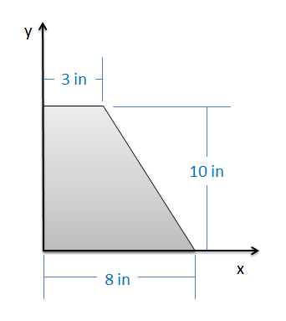

Solution: XC = 2.94 in, YC = 4.24 in

Problem A2.2

A water tank as shown below takes the form of an inverted, truncated cone. The diameter of the base is 4 ft, the diameter of the top is 8 ft, and the height of the tank is 4 ft. Using integration, determine the height of the center of mass of the filled tank. (Assume tank is filled with water and the walls have negligible mass)

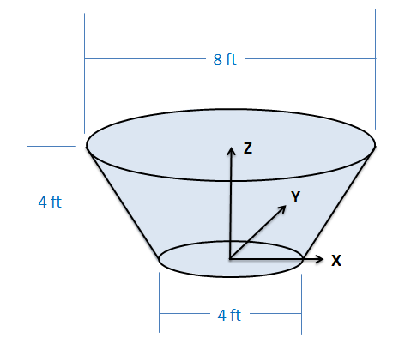

Solution: ZC = 2.43 ft

Problem A2.3

Use the method of composite parts to determine the centroid of the shape shown below.

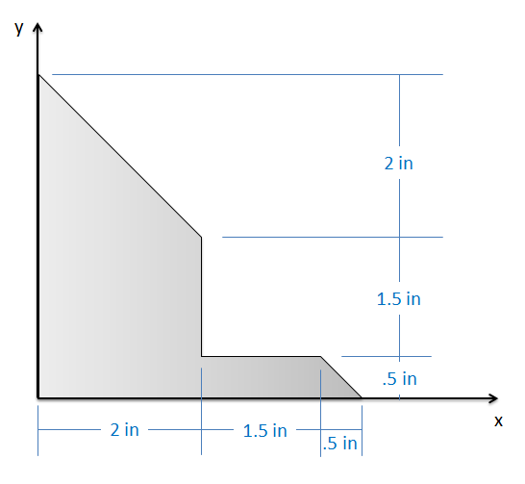

Solution: XC = 1.14 in, YC = 1.39 in

Problem A2.4

A floating platform consists of a square piece of plywood weighing 50 lbs with a negligible thickness on top of a rectangular prism of a foam material weighing 100 lbs as shown below. Based on this information, what is the location of the center of mass for the floating platform?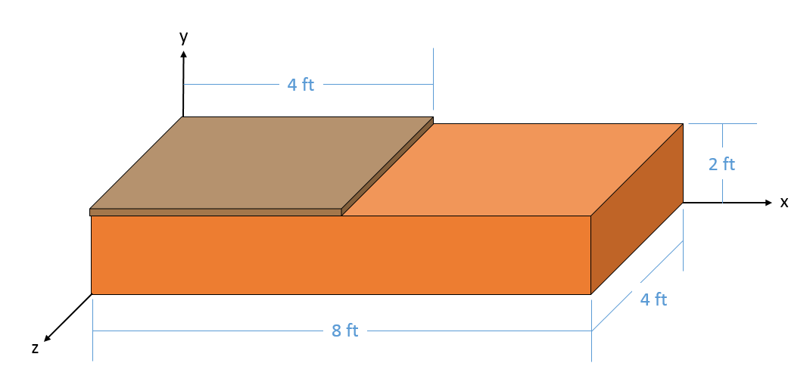

Solution: XC = 3.33 ft, YC = 1.33 ft, ZC = 2 ft

Problem A2.5

Use the integration method to find the moments of inertia for the shape shown below…

1. About the x axis through the centroid.
2. About the y axis through the centroid.

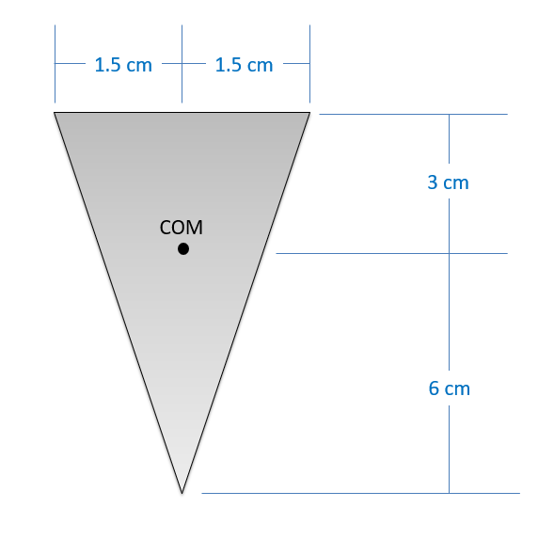

Solution: Ixx = 6.075\*10-7 m4, Iyy = 5.0625\*10-8 m4

Problem A2.6

The pendulum in an antique clock consists of a 6 cm brass disc with a mass of .25 kg at the end of a slender wooden rod with a mass of .1 kg. Determine the mass moment of inertia of the pendulum about the top of the rod.

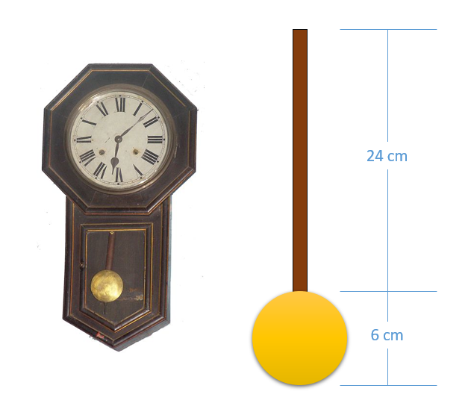

(Solution: )

Problem A2.7

A space telescope can be approximated as a 600 kg cylinder with a 4-meter diameter and 4-meter height attached to two 100 kg solar panels as shown below. What is the approximate mass moment of inertia for the space telescope about the y axis shown?

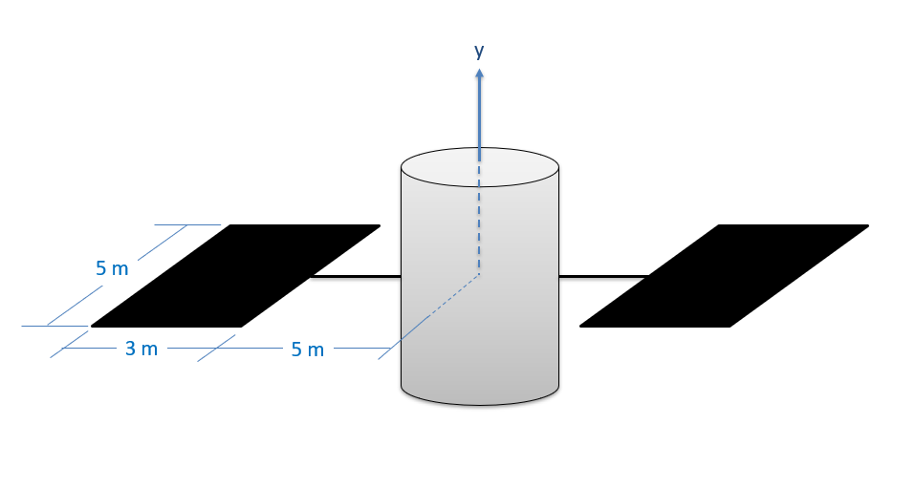

(Solution: )

Problem A2.8

A flywheel has an original weight of 15 pounds and a diameter of 6 inches. To reduce the weight, four two-inch diameter holes are drilled into the flywheel, each leaving half an inch to the outside edge as shown below. What was the original polar mass moment of about the center point? Assuming a uniform thickness, what is the new mass moment of inertia after drilling in the holes? (Hint: holes count as negative mass in the mass moment calculations)

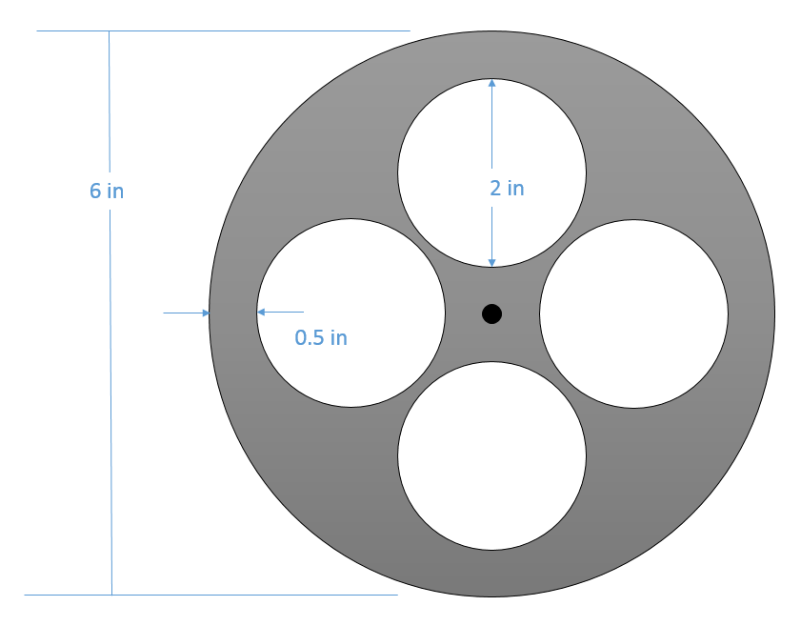

(Solution: Jwithout holes = .01456 slug ft2, Jwith holes = .01060 slug ft2)